SW2 – Project Evaluation Form
- Each team must submit the following Documentation that contains:
- Project Description in detail.
- Class Diagram. And Database Schema.
- Each team must submit the project via GitHub:
- Source Code.
- Video Demo for running ( 2 – 5 Minutes ).
- Documentation and Evaluation Form.
- The Evaluation will start with giving all teams 30 marks then check the following criteria:
Violation Level | Full | Medium | Small | Grade
Documentation | -5 | -2 | -1
Not Apply MVC (it does not Separate Business logic from GUI ). Example of violation: write an implementation for a method such as an inset item into the database inside the Button Action method | -6 | - 3 | -1
Violate clean code – Variables | -2 | -1 | -.05
Violate clean code – Functions | -2 | -1 | -.05
Violate Single-responsibility Principle | -2 | -1 | -.05
Violate Open-closed Principle | -2 | -1 | -.05
Violate the Liskov Substitution Principle | -2 | -1 | -.05
Violate Interface Segregation Principle | -2 | -1 | -.05
Violate Dependency Inversion Principle | -2 | -1 | -.05
Not Upload code to GitHub | -1
Only One Branch Without Merge (GitHub) | -2
Only One Contribution (GitHub) | -2
Total Minus from Grade
Design Pattern Bounce | +4
Bounce on Overall Work | +2
Total Team Grade / 30

Name (Arabic) | ID | Individual Bounce +2 | Grade
عبدالله أسامة حسن ابراهيم | 201900453
عجمى شعبان ابراهيم ابو الحديد المقدم | 201900474
محمد احمد السيد احمد قنديل | 201900619
عمر احمد شعبان محمد | 201900499
عمر مختار محمد عبدالفتاح | 201900533
عبدالله أحمد حسن سلامه | 201900452

Project description
An online book shop for selling books you can create an account, view books, comment, reply and finally buy a book an admin can add book, delete book, add a category.
Use case diagram
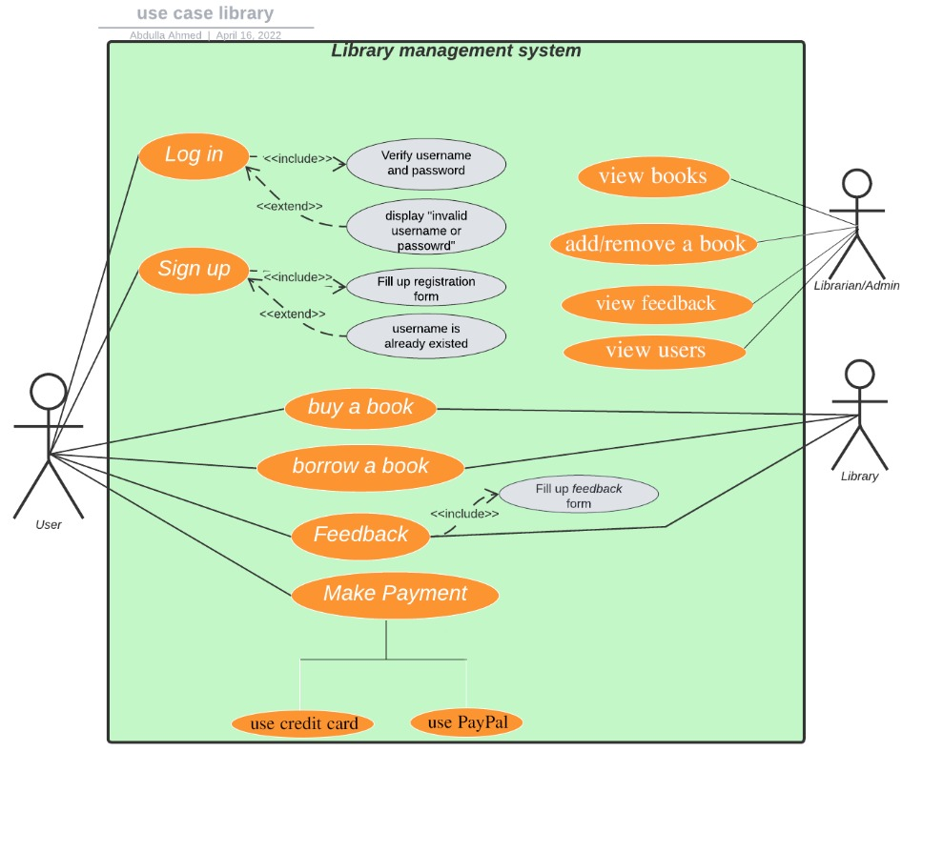

Activity diagrams
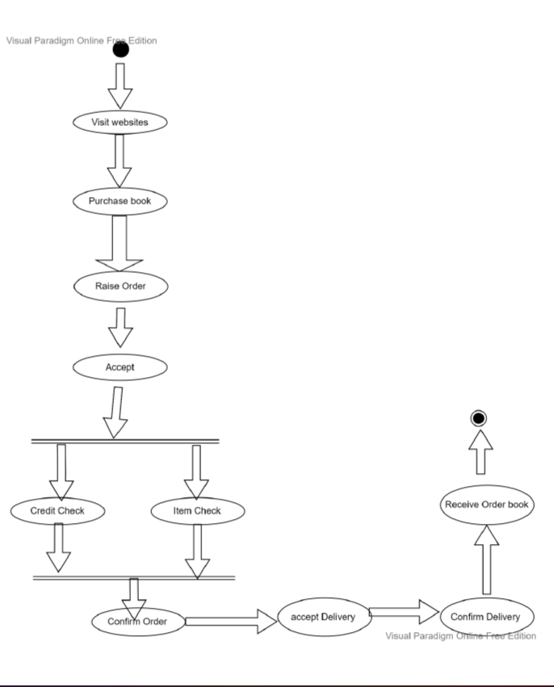
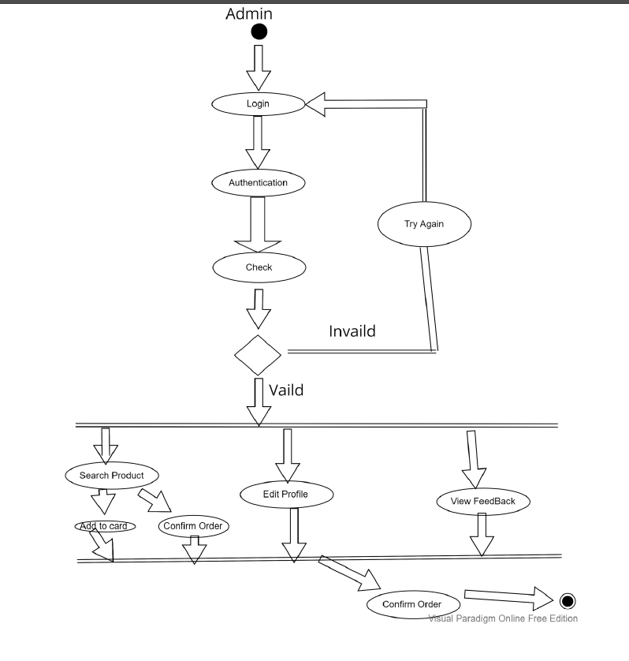
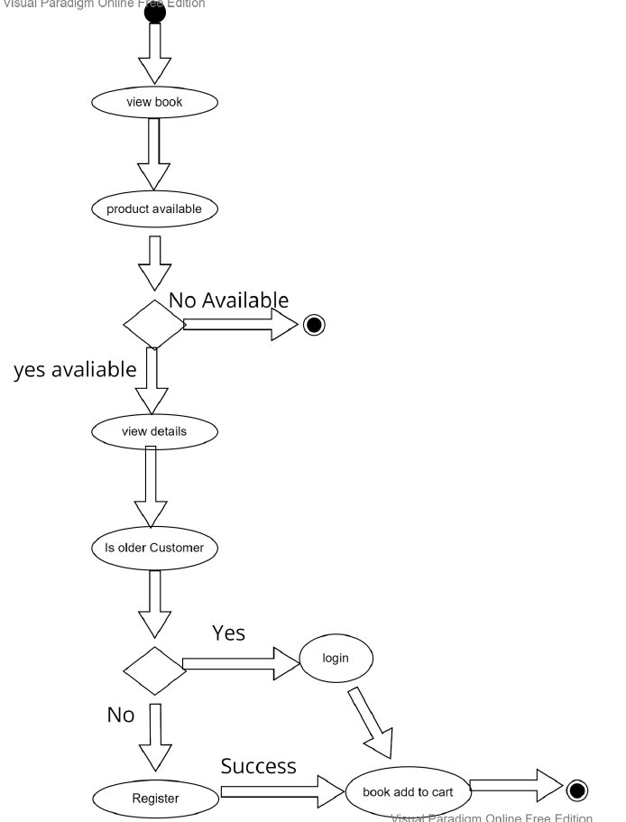

Database schema
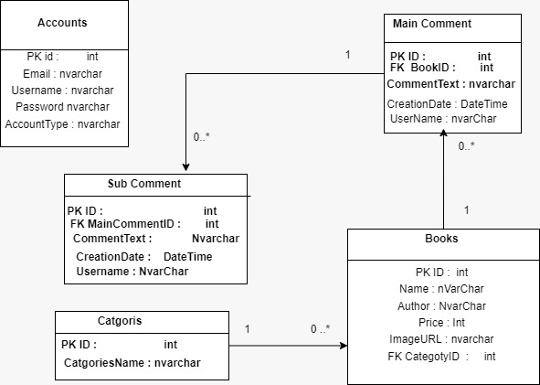

Class Diagram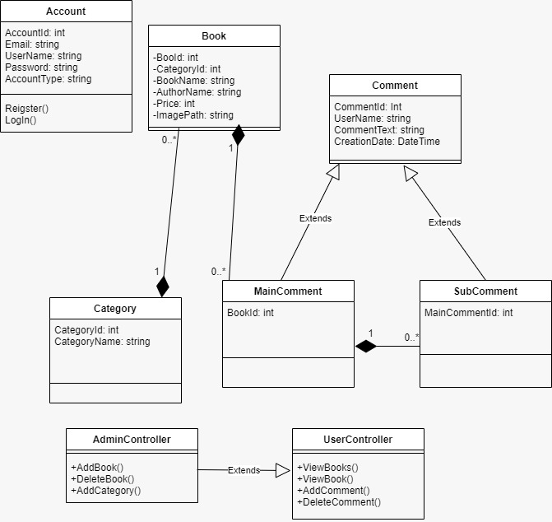

Sequence diagrams
Admin login:

Registration:

Add New Book:

Drop book:
View Book:

Book the Book:
Rate Book:

